# 1. Introduction

## 1.1 General Discussion:

There are a number of sounds present all around us and these sounds can be easily processed and identidied by the human brains. But for a machine or an artificial technology this is not that easy . For making a sense to the machine , we have to train the models with some pre-labelled datasets . Using the machine learning and Artificial Intelligence humans have developed some tools and ideas which can train the machine and make them efficient for various of like predication and categorization . In this project we are going to do some work in the field of the cateforization. We are going to bulid models with an efficient approach which can make the machines to identify sounds of some particular type .

Nowadays, Machine learning is growing rapidly. It has many areas like classification, regression and future prediction. Within, Past few years, there has been large development in the machines in the field of Image classification and some of the audio and signal classification in speech, music related areas. In this project, we are putting a step on Machine learning and making a UrbanSound8k classifier that’s may help or assist people with disabilities and want to know the surroundings around them.

## 1.2 Problem Statement:

In this project, we are putting a step on Machine learning and making a UrbanSound8k classifier that’s may help or assist people with disabilities and want to know the surroundings around them.

The overall objective of this project is to study the urban sound datasets and to implement the various models to recognize the urban sound events from the UrbanSound8K datasets.

## 1.3 Empirical Study on the Urban Sound Classification :

Nowadays, Machine learning is growing rapidly. It has many areas like classification, regression and future prediction. Within, Past few years, there has been large development in the machines in the field of Image classification and some of the audio and signal classification in speech, music related areas.A number of research and study has been done the classification of sound and hence identification of sound. Therefore the classification of audio or sound has been a gread field in the research area . Some of them have really proven to be useful in the real life with an accurate working. Urban Sounds category is one of them , one which several research and work have been done and still a lots of study is being done on this because this field is a major part where machines are frequentyl utilsed in real life.

## 1.4 Project Dataset and Approach to the problems :

In the dataset of UrbanSounds8k, there is 10 classes or we can say that 10 events are present i.e. Car Horn, Children Playing, Dog barking, Air Conditioner, Gun shots, Drilling, Street Music, Jackhammers, Sirens and Engine Idling. Every audio in the dataset is in the format of WAV(<=4s) and it is from the above mentioned 10 events. Dataset contain total of 8732 labelled sound of all the above mentioned 10 events. Apart from the dataset, we have a CSV file in which we have all the details like event sound is from background or foreground, from which clip it is cut from (audio clip), where to where (start and end time of slice), its event id, event name and in folder it is located.

The environmental sounds include strong Spectro-temporal signatures. We have to consider non-stationary aspects of signal and capture its variation in both time and frequency domains. The classification of environmental sounds is often split into auditory scene classification and sound classification by its source. The basic approach to the project would be the data pre-processing and feature extraction. We get the features using various signal processing techniques such as MFCC (Mel-Frequency Cepstral Coefficient), Mel Spectrogram , Spectral Centroid and so on. Librosa is an important library which can be used in the feature extraction. We are going to implement different approach and different models in order to bring out the best accuracy of sound event recognition.We will create classification models for classifying 10 given classes using ANN,RNN and CNN model.

## 1.5 Significance of the Problem :

The classification of sound has a lot of applications in the large scale and on the content based multi-media indexing as well as retrival. Now due to increase in the multimedia sensor network and due to a large quantity of online multimedia content , focus on urban sound classification has become important . Urban sound classification system can also help in the area of health services and communication. For example , in health services , if a person is having disabilities of recognizing the sound of the surrounding then this classfication can be helpful at some extent if this system is further improved in the future.

# 2. Review of the literature

## 2.1 Summary of the papers studied :

* Environmental Audio Classification using Convolutional Recurrent Neural Networks [2]

This paper gives an appoach of classifying a sound signal using CNN(Convolutional Neural Network). It just evaluates the accuracy of convolutional neural network in classifying environmental sounds of short audio clips. The model just consists of two convolutional layer with max-pool and two fully connected layer and this model is trained with segmented spectrogram features . The accuracy for the dataset [1] comes out to be 73.7%. The number of classes among which the model had to categorize were 10 . The name of those classes are : Air conditioner, car horn , childern playing , engine idling, drilling , JackHammer , Dog bark, gun shot firing , Street music and siren. The perfomance for air conditioner, car horn , Dog bark and playing children was good but not good for rest of the classes.

* Deep Convolutional Neural Network for Classifying Urban Sound [4]

The main purpose of this paper was to research the issue generated in classifying the urban sound using CNN. It just highlight the performance of audio categorization based on the spectrogram inputs. The confusion matrix generated in the process and the obtained result says that the time resolution index plays impotant role in the sound categorization performaces . The conclusion says that for the input of moderate time resolution gives the best performances on classification.

## 2.2 Integrated summary of the literature

We have studied the above mentioned papers. We have got to now the types of problems that can be faced during the implementation of the models. Basically urban sounds are unstructured sounds . These sounds may have real life noises like winds, public transportation , birds’ chirping and many other environmental noise. While structured sounds like music , speech and audio signal are different and does not contain any noises. Therefor noise is a problem in the urban sound classification. The real life datasets may contain the targeted audio either in the backgroud or in the foreground. So first of all we have to detect whether sound is coming from backgroud or foreground. After that we can go further in the process of classification. Before implementing any model on the audio set , it is important that we preprocess the audio signal into proper format for the visualization.

All the sound wave can be represented in terms of time domain and frequency domain . This representation can help in the visualization of the sound wave. Their representation in terms of time,frequency, ampliture etc. can be view as an image. That is the key features in the classification. Now we can implement any methods that can be applied in detecting an image . Different papers have suggested different technique in the features extraction based on the available dataset .Once the steps corresponding to the feature extraction has been completed , we can implement many machine learning models for the classification. Also [3] says the main challenge with the urban set can be handling the environmental noise because of multiple sources of sound.Also the number of datasets plays important role in the accuate classification . They should be large enough as well as the distrubution of all available class among which classification is to be done , must be uniform. This helps in the better learning of the model.

The environmental sounds include strong Spectro-temporal signatures. We have to consider non-stationary aspects of signal and capture its variation in both time and frequency domains. The classification of environmental sounds is often split into auditory scene classification and sound classification by its source.We can get different number of features from the sound wave like MFCC , Mel Spectrogram, Certroid Spectral , chroma -vector and so on. These features have resulted into the best accuracy so far .There are some parts that have been found common to all. The classification of sound generally work on three stages :

At first , Preprocessing the audio signal and then extracting some specific features and then finally classification of the audio signal using some popular models like ANN , CNN , RNN etc. For the features extraction , we can use MFCC( Mel -Frequency Ceptral Spectrum) , Mel-Spectrogram , Spectral Contrast, chroma_stft , tonezz etc. We can get these features by using Librosa audio package in python.For solving the classication problem on extracted feature

# 3 Report on Present Investigation

## 3.1 Experimental Setup

For the analysis of our project , we have used Urban Sound8K [1] which comprehends 10 day to day sounds taken from the urban areas which are namely barking dogs, children playing , gun shot , drilling machine, street music , jackhammer,vehicle horns ,air conditioner , sirens and engine idling. The datset contains exactly 8732 marked audio samples and the duration of each of sample is either less than 4 sec or less than 4 sec , forming duration of 9.7 hours in total.All the 8732 audio samples of urban sounds are in the WAV format.

The dataset has been metamorphosed into 10 folds but it is nothing like that each fold contains the dataset for single classes each. They are well shuffled and ensure that the distrubution of training and testing data are proper and indiscriminate. The audio signs were examined to 8 kHz and were normalized to zero mean .

There is a meta-datafile included along with the audio samples in the dataset. This file contains the information of meta-data about every audio file in the dataset. These include following :

* Slide_file_name - This is the name of the audio file . All the names take the following fomat : [fsID]-[classID]-[occurrenceID]-[sliceID].wav where

[fsID] represents the Freesound ID of the recording from where this slice has been taken

[classID] represents an identifier(numeric form) of the audio class

[occurrenceID] represents an identifier(numeric form) to distinguish different occurrences of the audio within the original recording

[sliceID] represents a numeric identifier to distinguish different slices taken from the same occurrence

* fsID: It represents the Freesound ID of the recording from where this slice has been taken.
* start: It represents the start time of the slice in the original recording.
* end : It represents the end time of the slice in the original recording.
* fold: It represnts the fold number where the audio file has been allocated . Its range are from 1 to 10.
* class : It represents the class name
* classID : classID represents the identifier in the numeric form.These are following :
  + air_conditioner -> 0
  + car_horn -> 1
  + children playing -> 2
  + dog_barking ->3
  + drilling -> 4
  + engine_idling ->5
  + gun_shot -> 6
  + jackhammer -> 7
  + siren -> 8
  + street_music -> 9

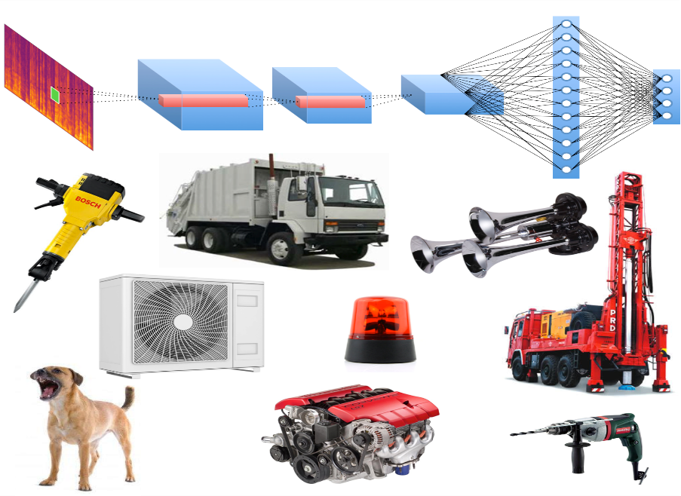

**Figure 1 : Showing the types of sounds genetated in urban area**

## 3.2 Procedures

### 3.2.1 Loading the data

For the audio classification problems , procedures are common to all. The procedure comprises of two steps. First step is extracting features and the second step is classification . In our project , we will be having same two the audio sample in our python file.The audio samples are continuous waves and these are digitized and converted into one-dimensional array by sampling them at discrete interim. Since these waves are one-dimensional array , therefore it can be used to represent a specific amplitude or a spicific frequency at the given time instance. However, we have used Librosa which is a python package and used for audio and music processing with predefined functions.Librosa also normalizes the data so that array value can be represented between -1 and 1.

### 3.2.2 Features Extraction

After loading the data, we have to extract the spectral features from the loaded data.There are various types of spectral features which can be used to visualize the audio data. Among all the available features , we will be working with MFCC, Mel spectrum, STFT , chroma_stft, RMS, spectral_centroid, Tonnetz , zero_crosssin_rate and chrome_cens.

### 3.2.3 Classification

As we extract the features from the loaded data, we can apply various methods for classification. The extracted features can be either in the form of one-dimensional array or two-dimensional array . So according to the dimension we can apply various classification algorithms . In this project will be majorly focussing on ANN(Articifical Neural Network) , CNN(Convolutional Neural Network) and RNN (Recurrent Neural Network).

## 3.3 Techniques Used in Feature Extraction

There are various spectral features which used in the analysis of audio samples .Some of them are MFCC (Mel Frequency Central Spectrum) , Mel Spectrogram , STFT , chroma_stft, RMS, spectral_centroid, Tonnez , zero_crosssin_rate etc. Let us see what does these features means :

### 3.3.1 Short Time Fourier Transform (STFT) :

Before we understand about **STFT** it is important to know about

**Fourier Transform** . When we audio samples over time , then we can only see the amplitude of the signal but if we want to see the amplitutde of specific frequency then then **Fourier Tranform** comes into the picture. So, basically Fourier Transform is a mathematical formula that allows to decompose any signal (in our case, audio signal) into its individual frequencies and the frequencie’s amplitude which is also known as spectrum.

We know that in case of non-periodic signal , the signal’s content varies over time. In that case , to represent a signal in the frequency domain , we take the help of window segments . We just compute several spectrum by performing fast Fourier Transform on several windowed segments of the signal. This process is called **Short Time Fourier Transform**.

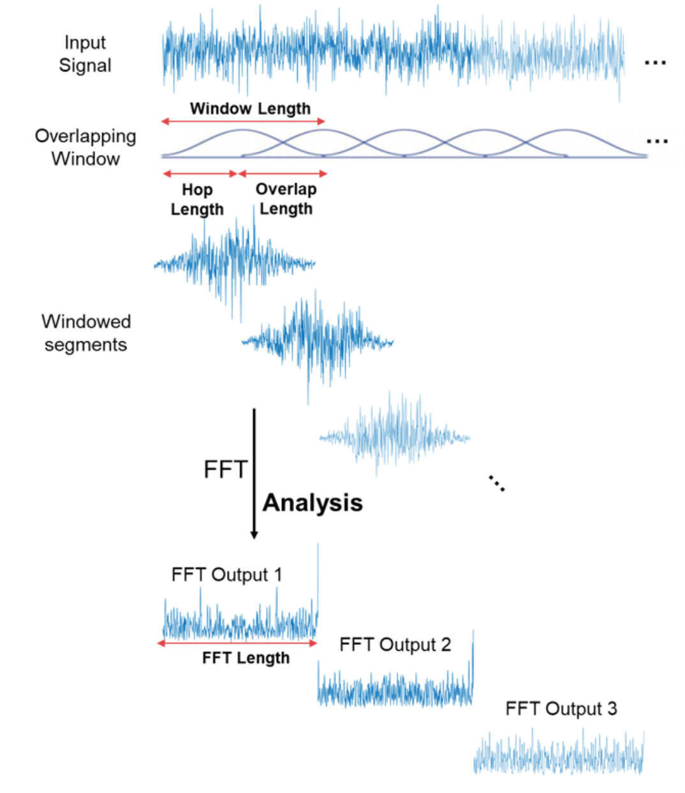

**Figure 2: Showing the process of STFT**

For extracting the STFT features from the audio samples , we have used librosa package in pyhton :

STFT = librosa.stft(y) where y represents input signal

### 3.3.2 Mel Spectrogram:

Mel Spectrogram is mainly derived from two words : Mel and Spectrogram.Here Mel is representing Mel Scale . Mel Scale is a king of scaling using for graphical representation. A Mel Scale is result of some non linear transformation of the frequency scale.The Mel Scale is constructed such that sounds of equal distance from each other on the Mel Scale.

The [5] formula used for converting normal scale frequency into Mel Scale is :

**M(f) = 1125 ln(1 +f/700)**

Where **f** is normal frequency

And to convert Mel Scale into normal frequency is

**M-1(m) =700*(exp(m/ 1125) -1)**

Where **m** is Mel Scale frequency

Now , in case of Short Time Fourier Transfrom , when we compute FFT on overlapping windowed segments of signal , we get **Spectrogram**.

Therefore simply we can derive that **Mel Spectrogram** is nothing but spectrogram where frequencies of the singnal are converted into the Mel scale.

For extracting the Mel Spectrogram features from the audio samples , we have used function of librosa package in pyhton :

Mel Spectrogram = librosa.feature.melspectrogram (y)

where y represents input signal

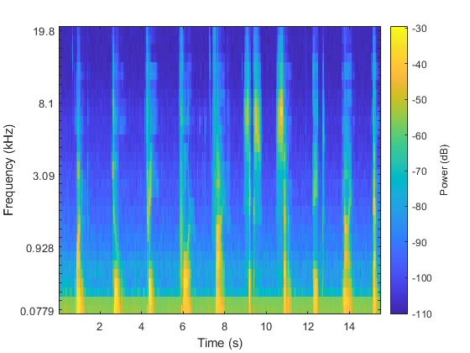 other other paramaters were passed according to the requirement.

Figure 3 : showing Mel Spectrogram of an audio sample

### 3.3.3 MFCC ( Mel Frequency Central Spectrum )

Mel Frequency Cepstral Coefficientare the feature of widely used in automatic speech and speaker recognition.These are the coefficients that collectively make up an MFC(Mel-Frequency cepstrum ). MFC is the representation of short-term power spectrum of sound which is based on the linear cosine transform of a log power spectrum on a nonlinear of freqeuency. MFCC are not very robust in presence of some additive noise and therefore it is common to normalize their values in sound recognition to lessen the influnce of noise.

MFCC can be derived in the following steps[5] :

1. Taking the fourier transfrom of the signal
2. Using Triangular overlapping windows, mapping the powers of the spectrum obtained on the mel scale.
3. At each of the mel frequencies taking the logs of the powers.
4. Viewing the mel log powers as a signal , take the discreate fourier transform .
5. The amplitute of the resulting spectrum are MFCCs.

For calculating MFCC from the input signal , we have used function of librosa package in pyhton :

MFCC = librosa.feature.mfcc (y)

where y represents input signal

other other paramaters were passed according to the requirement.

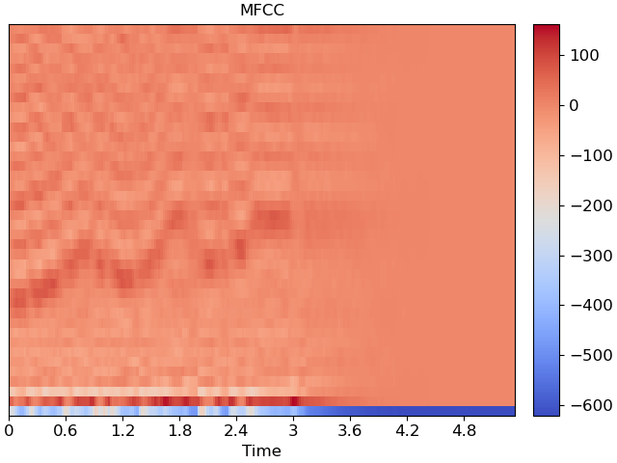

Figure 4 representing MFCC features of an audio sample

### 3.3.4 Chroma STFT

Basically the chroma value of audio singal represents the intensity of the twelve distinctive pitch classes.These classes are mainly used to study music. The chromagram just extends the concept of chroma for including the dimension of time . Just as we see that the spectrogram is used to infer the properties about the distribution of energy of signal over the frequency and time , the chromagram can also be used to infer the properties about the distribution of energy of signal over chroma and time. We can also view chromagram as a many to one mapping of the signal strength at the frequencies which belong to the same chroma class. The STFT here describes the information about the classification of signal and pitch structure.

We can compute chroma_stft in two stages[6] :

1.Computing the spectrogram

The first stage includes the generation of an image in time-frequency relation.It localizes the distribution of signal’s energy in as a function of time and frequency.The spectrogram is one such efficient method .

2. Construction of time-chroma image

Based on the spectrogram which previously computed a time-frequency image , we can construct time-chroma image using many to one mapping.

For calculating chroma STFT from the input signal , we have used function of librosa package in pyhton :

chroma_stft = librosa.feature.chroma_stft (y)

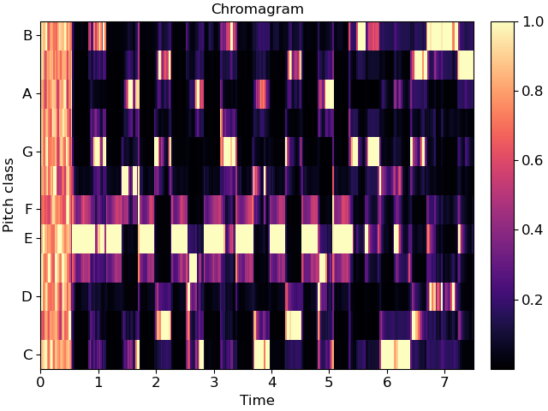where y represents input signal

Figure 5: showing the Chromagram of Spectogram of an audio signal

### 3.3.5 RMS(Root Mean Square) Energy

For measuring the level of audio, there are mainly two ways. First one is Peak and second is RMS (Root Mean Square) . While Peak measures the highest level of produced audio , **Root Mean Square** just quantifies the signal’s level.It correlated more closely to the hearing.

Mathematically RMS Energy can be derived as

RMSE = 2

Where x(n) represents the magniture of the singnal and n represnts total number of discrete time.

For calculating RMS value from the input signal , we have used function of librosa package in pyhton :

RMS value for each frame = librosa.feature.rms (y,frame_length)

where y represents audio time series and frame_length represents length of analysis frame for calculation of energy.

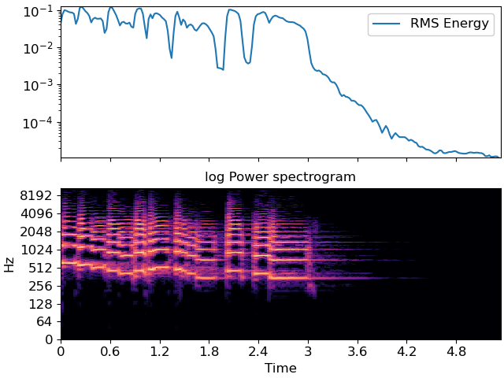

Figure 6 showing the RMS energy of an audio sample

### 3.3.6 Zero-Crossing-Rate

**Zero-Crossing-Rate (ZCR)** mainly represents the rate at which the signal changes sign in a frame i.e. from negative to zero to positive or from positive to zero to negative. In the other way we can say that the number of times the signal crosses the x-axis or horizontal axis where x-axis represents the time.

Zero Crossing Rate is mainly high for the noisy or unvoiced audio and low for voiced sound.The smoothness of a singla can be calculated using zero crossing rate.

For calculating ZCR from the input signal , we have used function of librosa package in pyhton :

zcr = librosa.feature.zero_crossing_rate (y)

where y represents input signal as audio time series . zcr[0,i] is the fraction of zero crossing in the ith frame.

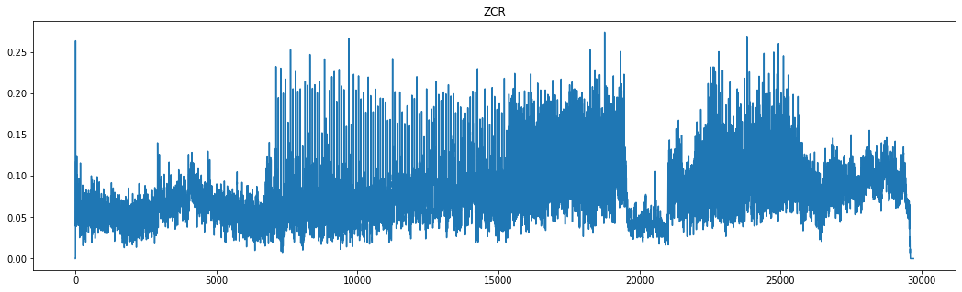

Figure 7 zero crossing rate of an audio sample

### 3.3.7 Spectral Centroid

Spectral Centroid is a features of sound which are mainly used in processing of digital signal in order to characterize a spectrum.It mainly indicates the point where whole spectrum can be seen as concentrated or we can say , center of mass of the spectrum.It is widely used in music processing and digital audio.

Mathematically , Spectral Centroid can be calculated as the weighted mean of signal frequencies with their magnitudes as weights.

Specteal Centroid = $\frac{\sum_{n=0}^{N-1}{f\left(n\right)x(n)}}{\sum_{n=0}^{n-1}{x(n)}}$

Where x(n) is value of weighted frequency of bin numner n and f(n) represent the center frequency of that bin.

For calculating spectral centroid from the input signal , we have used function of librosa package in pyhton :

Spectral_centroid = librosa.feature.spectral_centroid (y,sr,n_fft)

here y represents audio time series, sr represnts sampling rate of y , and n_fft represents fast fourier transfrom window size.

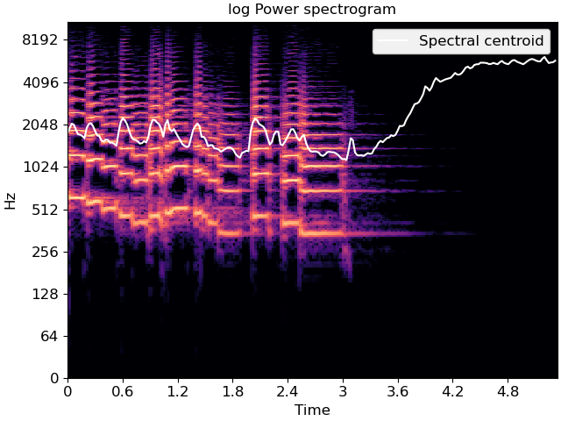

Figure 8 showing the spectal centroid of a signal

### 3.3.8 Tonnetz

Tonnetz are another feature extraction technique which computes the tonal centroid features by sensing the hormonic change in the audio clips.

For calculating tonal centroid features from the input signal , we have used function of librosa package in pyhton :

t = librosa.feature. tonnetz (y,sr)

here y represents audio time series and sr represnts sampling rate of input signal. The returned value t is tonal centroid features for each frame.



Figure 9 tonnal centroid of an audio clip of dog_bark class

## 3.4 Methods used for classification

### 3.4.1 ANN (Artificial Neural Network )

Artificaial Neural Network can be simply called Neural Network. ANN model consists of a collection of simulated neurons. Each neuron in ANN is a node which is well connected to other nodes via the links that correspond to the biological axon-synapse-dendrite connections. All the links have their own weight, which determine the strengths of node's influence on other nodes.

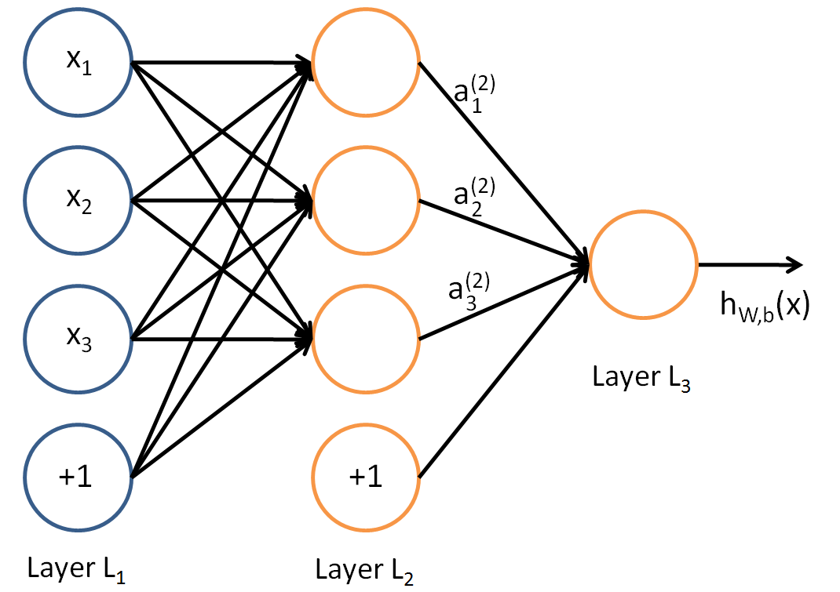

Figure 10 represneting an Artificial Neural Network

In figure 10, circles have been used to denote the **neuron** inside the network.The circles which are labelled as +1 are known as bias units and mainly corresponds to the term Intercept.

* The leftmost layer present in the netowk is called **input layer** which is used to feed the input to the model .
* The middle layer present in the network is known as **hidden layer**.This layer is called hidden because in the training set , values of this layer is not observed.
* The rightmost layer present in the network is known as **output layer** which gives us the output of the model.

Mathematical expression [7] :

Artificial Neural Network consists of basic computational units called neurons.Let us assume for each neuron , it takes input as x1 , x2, x3,.. xk.

Fout = fsigmod(WT x) = fsigmod( )

Where W is the weights and b is the bias. fsigmod is a sigmoid function . Sigmoid is one of the activation function and can be derived as :

fsigmoid (x) =

A simple neural network generally contains only one hidden layer, but it a neural network may contain multiple hidden layers.Let us suppose in layer k , there are n neurons and the sum of weighted input of ith neurons in kth layer is oi(k) then we get the oi(k+1) by following eqution[7] :

For k=1, oi(2) =

For k>=2

oi(k+1) =

### 3.4.2 CNN (Convolutional Neural Network)

A **CNN** (Convolutional Neural Network) is a kind of feed forward neural network that is generally used to analyse the data as a visual images. A CNN has many hidden layers which help in extracting information from an image:



Figure 11 extracted audio features being forwared to a CNN model

* **Convolutional layer** is the first layer in the process of extracting features from an image.A convolutional layer has several files that perform the convolutional operation.
* **Pooling layer** is the layer that summerises the features present in the region of the feature map generated by a convolutional layer.It is used to reduce the dimensions of the feature maps.Therefore,it reduces the number of parameters to learn and the amount of computation performed in the network..
* **Relu Layer(Rectified Linear Unit)** performs an element-wise operation ans set all the negative values to zero. It introduces non-linearity to the netowork. It speeds up the training andd the gradient computation becomes simple.
* **Flattern Layer** is used to convert the output of convolutional layers into a one-dimensional array so that it is to be inputted into next hidden layers.
* **Dense Layer** is a popular and frequently used layer in Convolutional Neural Network. It represents a matrix vector multiplication. It is used to change the dimension of the vector.For example dense layer applies scaling, rotation , transform of the vector etc.
* **Dropout Layer** : A dropout layer is mainly used for the regularization .This layer prevents the neural from overfitting.Dropout can be implemented on any of the hidden layers but not on the output layer.

The architecture of CNN model is similar to a Deep neural Network . Both the models have hierarchies of interconnected neurons. They mainly differs to each other by the their usage of convolutional layers for the processsing of image-related inputs.

### 3.4.3 RNN (Recurrent Neural Network)

Recurrent Neural Network is simply a generalised form of feedforward Neural Netowrk which has an internal memorty. For every input of data , the RNN performs the same function but the output of the current input depends on the output of past one , therfore we called RNN , recurrent in Nature. After the output is generated it is sent back into the recurrent network . Therefore for making a decision , RNN considers both : the current input and the output that has been learned in the previous input.

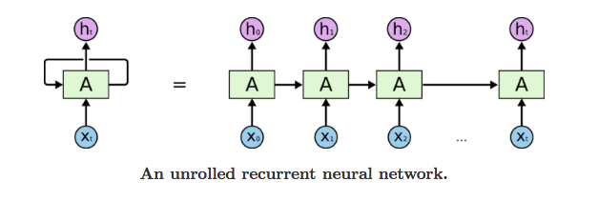

Figure 12 unrolled network of a RNN Model

Let us understand with figure 12 .First it takes x(0) from the input sequence and then it computes output h(0) . This h(0) along with the x(1) will be the input for the next step. Similarly the computed output h(1) from this state along with the x(2) will be the input for the next step and so on.

The formula[8] for the current state is :

ht = tanh(Whhht-1 + WxhXt)

where W is weight , Whh represents the weight of the previous state , Wxh is the weight at current input and tanh is a type of activation function , that are non-linear in nature and output values between -1 to +1. It’s equation[8] is :

tanh(x) = 2/(1 + e-2x) - 1

The formlua[8] for the output state in RNN is :

Yt =Whyht

Where Yt  represents output state and Why represnets the weight at the output state.

**LSTM (Long Short Term Memory)**

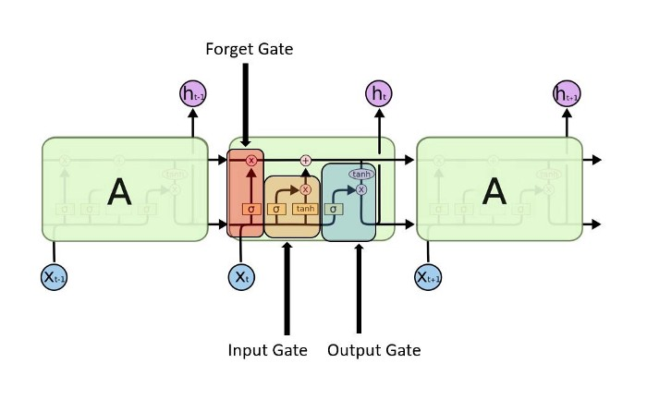Long Short Term Memory Networks is an extended version of Recurrent neural network. LSTM makes the model easier to remember the past data of the memory.Also the problems which happens in RNN like vanishing gradient problem or the problems of remembering long memory can be resolved using this model.LSTM trains the model by using the back propagation.

Figure 13 different gates present in LSTM model

In an LSTM network , there are mainly three gates present :

* Input Gate : Input gate manages which value from the input shoud be used to mofify the memory.This is decided by the Sigmoid Function through 0 and 1 . The weightage of the values that are passed are given by tans function . So tanh function decides the importance of a value passed by using range -1 to 1.
* Forget Gate : Forget gate discovers all the details which are to be discarded from the memory block.This is managed by sigmoid function.It just looks the current input and previous state and outputs a numner either 0 or 1. If it is zero , it means details to be omitted otherwise keep the details in case of 1.
* Output Gate : To decide the output , the input and the memory of the block is used . This is decided by sigmoid function through value 0 and 1. In addition to this , tanh function gives the weightage of the values being passed which decides the level of importance ranging from -1 to 1.

## 3.5 Implementation of the Project

### 3.5.1 Python Libraries we used

* **Keras:** This is an open source library that provide an interface to Neural Networks. It support multiple backends, including tensorflow, theono. It is used for building blocks such as layers, objectives, activation function, optimizers and a host of tools to make working with image and text data easier to simplify the coding necessary for writing deep neural network code.
* **Numpy:** this is an open source library that support multi-dimension array and matrices, along with a large collection of high-level mathematics functions to operate on these array.
* **Sklearn:** It is also known as scikit learn and it is an open source library that provide various features on machine learning like classification, regression and clustering algorithms including SVM, random forest etc.
* **Librosa:** This is the library for music and audio analysis. It provide the building blocks necessary to create music information retrieval system.
* **Pandas:** It is fast, powerful, flexible and easy to use open source data analysis and manipulation tool.
* **Matplotlib.pyplot:** It provide MATLAB like way of plotting and easy to use for plotting different types of graphs to understand or analyse the data.

### 3.5.2 Data Preprocessing

Data Preprocessing is the method by which we make the raw data trainable to machine learning. To do this so, we use librosa library to convert sound in numpy array.

This code we have used to convert sound into numpy array:

import librosa

sound, sample_rate = librosa.load( PATH, res_type = 'kaiser_fast' )

Here, sound is numpy array which represent the sound, sample_rate is the sampling rate of the sound, PATH is the position of file in our system and we use ‘kaiser_fast’ res_type to convert sound into numpy array.

And also we know that every sound is <=4sec which is very inconsistent for us to maintain the data. To make this consistent we used 2 methods:

1. Repeating Sound

We repeat the sound and make echo of original short sound till 4 seconds. Here below we can see the difference in the graph of car horn sound.

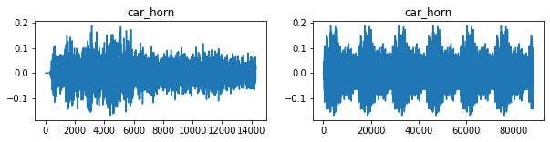

This is the code we use for this preprocessing

*z = 0;*

*while( len(sound) < 4*sample_rate):*

*sound = np.append(sound, sound[z])*

*z += 1*

1. Zero padding at the end

We add zero to the end of the sound which means no sound once activity overs. Here below we can see the difference in the graph of same car horn as above shown for better understanding.

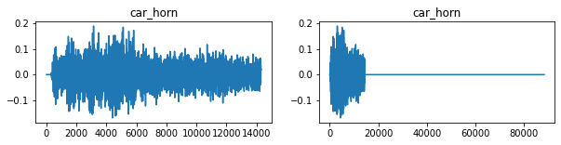

This is the code we use for this preprocessing

*z = 0;*

*while( len(sound) < 4*sample_rate):*

*sound = np.append(sound, 0)*

*z += 1*

After this data preprocessing every sound is of 4 second which is very consistent or easy to handle as compare to its raw data.

### 3.5.3 Model Layers which we use in this projects

Neural Network or Deep Learning model consist of variety of different layers in it and also we have to understand the purpose of all the different layers to understand the working of our model and its significance. Model layers are like passing the information and interpreting like brain and understanding input and do some calculations to give some outputs.

Basically there are 3 types of Layers in any neural network Models:

1. Input layer
2. Hidden layers
3. Output layer

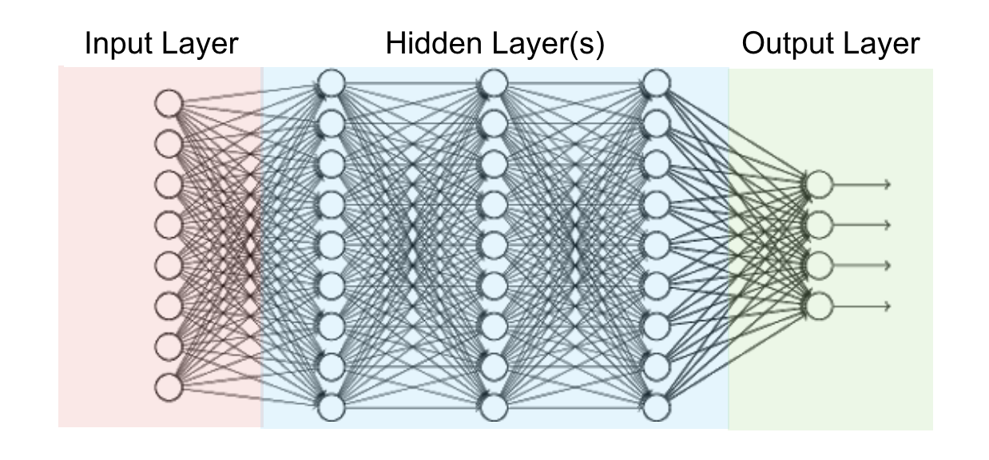

Figure 14 Basic representation of Neural Network in terms of layers.

1. **Input layer:**

This is the most fundamental layer of all layers because without any input we can’t determine any kind of output/result. In simple language we can say that there is no need of any algorithm where we can’t find any input to produce results.

It depends on many type of inputs like:

* Grayscale image/2D image
* RGB Colored image/3D image
* Sequenced Data

Input layers can perform some functions like smoothing the input data, normalization of the input data etc.

1. **Hidden Layers:**

Hidden layers consist of at least 1 layer other than input and output layer. There is variety of layers we can use to create a hidden layers. Its main purpose is to do some calculation on input layers and a matrix such that it can produce the output layer.

Here, we are going to discuss some of the major layers we used in our projects for better understanding of our models:

* ***Convolution Layer***

Convolution layer are the major building blocks used in Convolution neural networks.

A convolution is a linear operation which means a multiplication of set of weights with the inputs. This technique is designed for 2D input and the multiplication is performed with this 2D input and the some random 2D array of weights that is mainly called as filter or kernel.

There are some rules for better results is Filter size must be smaller than the input size.

And the output of dot product/multiplication of filter and the input is called ‘feature map’.

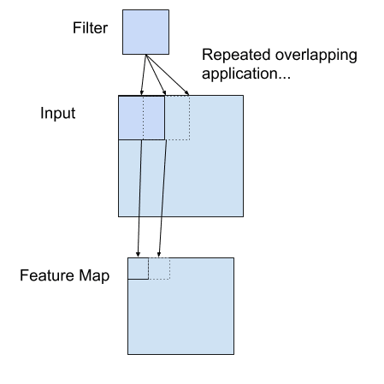

Figure 15: convolutional layer

* ***Pooling Layer***

Pooling layers is used to reduce the sensitivity of the location of features. It means it reduces the number of parameters to learn and the amount of computation performance in Neural Networks.

Pooling layer summarized the features of feature map generated by Convolution layer. So, further operation is performed on the pooling layer means on summarized feature of feature map instead of feature map of convolution layer.

We use only 3 types of pooling layers in our models:

1. Max Pooling layer

Max Pooling layers is the pooling that selects the only feature that dominants in the feature map of in that fixed filter.

Here, we can see the example.

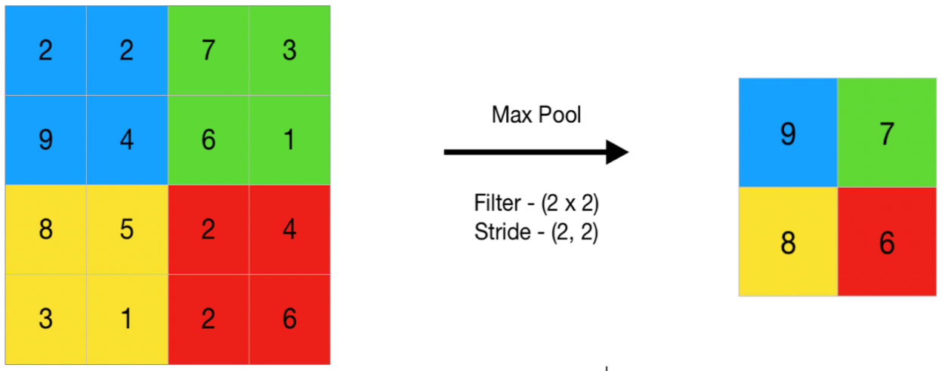

1. Min pooling layer

Min pooling layers is the pooling that selects the only feature that least significant in the feature map of in that fixed filter.

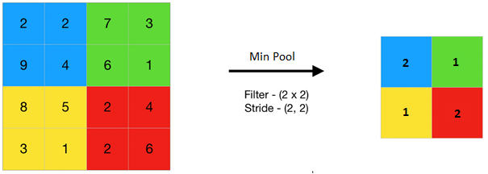Here, we can see the example.

1. Average pooling layer

Average Pooling layers is the pooling that average the all the value in the filter.

Here, we can see the example.

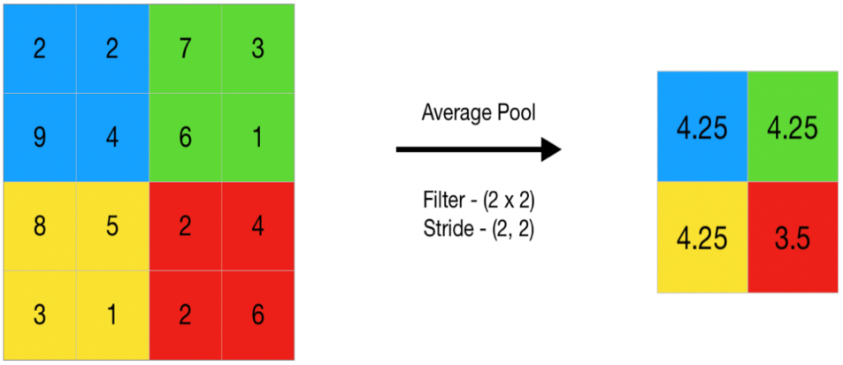

* ***Activation Layer***

Activation layer used to introduce the non-linearity into the output of hidden layers. Basically we need activation layer in neural network because neuron can’t learn with just a linear function attach to it. A non- linear function will help it to learn as per difference with respect to errors.

There are too many activation function we can use in activation layer but we mainly use only 2 activation function:

1. RELU

It stands for Rectified Linear Unit. It is very common in Neural network and deep learning.

Equation: A(x)=max(0,x)

It give the output 0 if x is negative, else x.

1. Softmax

It usually used for handling multiple classes and it squeeze the output in range 0 to 1. It is also used to attain the probability of all the classes for each inputs.

* ***Batch normalization layer***

Batch normalization layer is use for normalizing the each input channel across a mini-batch. This layer first normalizes the activation of each channel by subtracting the mini-batch mean and dividing by the min-batch standard variation.

After that, the layer shifts the input by a learnable offset and scale it by a learnable factor. It reduce the sensitivity of the network initialization.

* ***Dropout layer***

Dropout layer is used for preventing overfitting the model by nullifying the some neurons or we can say that setting randomly some of the inputs unit to 0 with some frequency at each step of training.

* ***Flatten layer***

Flatten layer use to flatten the input layer. For example a input is define as the (batch_size,number_of_features,channels), after applying the flattern the output is (batch_size,new_features) where

new_feature size = number_of_features*channels.

* ***Dense layer***

Dense layer is fully connected neural networks layer. This is most frequently and commonly used in Neural Network. It basically do dot product of input layer with sets of weights that is called kernel with adding some bias in it. And its result/output passes to the next layer.

* ***LSTM layer***

LSTM is stand for long short term memory. It is kind of RNN (Recurrent Neural networks). LSTM can retain the information for the long period of time. It is used for processing, predicting and classifying on the basis of time series data.

1. **Output Layer:**

Output layer is the last layer of the model that we created, which produce the end results

.

### 3.5.4 Implementation of ANN Model

Steps involved :

1. *Data Preprocessing:*
2. In data preprocessing, we simply convert sound into numpy array

*import librosa*

*sound,sr=librosa.load(PATH,res_type='kaiser_fast')*

1. After that we extract features with sound numpy array

For example with mfcc feature extraction:

*mfccs = librosa.feature.mfcc(sound, sr=sr,n_mfcc=40)*

1. After that we average the all the time stamps to all the feature vectors

By writing the below line

*data=np.mean(data,axis=1)*

1. Repeated all the above steps for all the every sound
2. Collection of above data is use for training, testing and validation of the ANN model

1. *Model Creation:*

We imported all the library we needed to do so.

Here, is the code of the model

*model=Sequential()*

*model.add(Dense(2048, activation='relu', input_shape=(60,)))*

*model.add(Dropout(0.5))*

*model.add(Dense(1024, activation='relu'))*

*model.add(Dropout(0.5))*

*model.add(Dense(512, activation='relu'))*

*model.add(Dropout(0.2))*

*model.add(Dense(512, activation='relu'))*

*model.add(Dropout(0.2))*

*model.add(Dense(128, activation='relu'))*

*model.add(Dropout(0.2))*

*model.add(Dense(128, activation='relu'))*

*model.add(Dropout(0.15))*

*model.add(Dense(64, activation='relu'))*

*model.add(Dropout(0.1))*

*model.add(Dense(10, activation='softmax'))*

*model.summary()*

1. *Model Architecture:*

The architecture has been shown in figure 16.

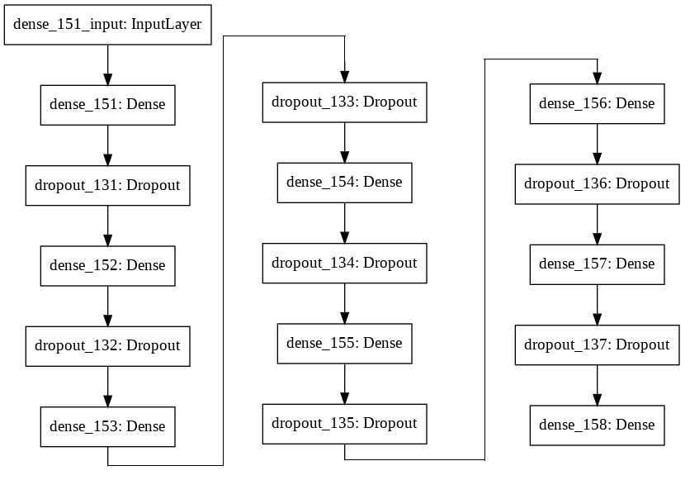

Figure 16 architecture of the ANN model

This is the architecture summary of the above implemnted model:

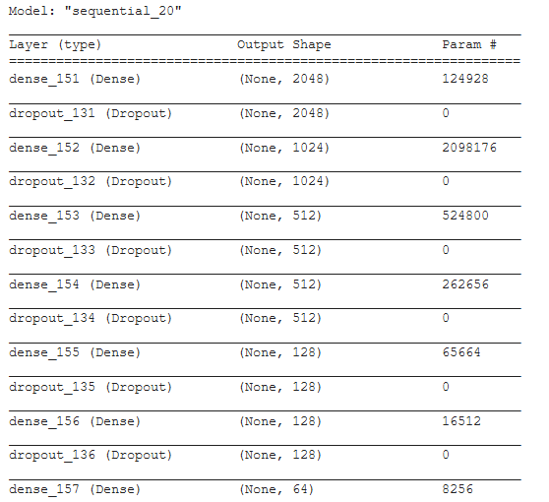

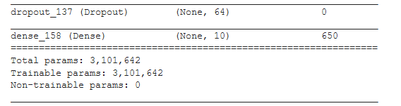

1. Compiling, Training and Testing
2. For compiling

*model.compile(optimizer='adam',*

*loss='categorical_crossentropy',*

*metrics=['accuracy'])*

1. For Training

*model.fit(x_train, y_train,*

*batch_size=256,*

*epochs=200,*

*callbacks=[PlotLossesKeras()],*

*verbose=1,*

*validation_data=(x_val, y_val))*

1. For Testing

*score = model.evaluate(x_test, y_test)*

*print(score)*

### 3.5.5 Implementation of CNN Model

1. Data Preprocessing:
2. In data preprocessing, we simply convert sound into numpy array

*import librosa*

*sound,sr=librosa.load(PATH,res_type='kaiser_fast')*

1. After that we choose any of the any of the above explained method i.e. Repeating sound, Zero Padding at the end to remove inconsistency.
2. After that we extract features with sound numpy array

For example with mfcc feature extraction:

*mfccs = librosa.feature.mfcc(sound, sr=sr,n_mfcc=40)*

1. Repeated all the above steps for all the every sound
2. Collection of above data is use for training, testing and validation of the CNN model

1. Model Creation:

We imported all the library we needed to do so.

Here, is the code of the model

*inputs= Input(shape=(60,173,1))*

*M0=Conv2D(filters=32,kernel_size=(5,5),padding='SAME',activation='relu',input_shape=(60,173,1))(inputs)*

*M0=BatchNormalization(momentum=0.2)(M0)*

*M0=Conv2D(filters=32,kernel_size=(3,3),padding='SAME',activation='relu')(M0)*

*M0=Conv2D(filters=32,kernel_size=(3,3),padding='SAME',activation='relu')(M0)*

*M0=Conv2D(filters=32,kernel_size=(3,3),padding='SAME',activation='relu')(M0)*

*M0=Conv2D(filters=32,kernel_size=(3,3),padding='SAME',activation='relu')(M0)*

*M0=AveragePooling2D(pool_size=(2,2))(M0)*

*M0=Conv2D(filters=64,kernel_size=(3,3),padding='SAME',activation='relu')(M0)*

*M0=Conv2D(filters=64,kernel_size=(3,3),padding='SAME',activation='relu')(M0)*

*M0=Conv2D(filters=64,kernel_size=(3,3),padding='SAME',activation='relu')(M0)*

*M0=AveragePooling2D(pool_size=(2,2))(M0)*

*M0=Conv2D(filters=128,kernel_size=(3,3),padding='SAME',activation='relu')(M0)*

*M0=Conv2D(filters=128,kernel_size=(3,3),padding='SAME',activation='relu')(M0)*

*M0=AveragePooling2D(pool_size=(2,2))(M0)*

*M0=Conv2D(filters=128,kernel_size=(3,3),padding='SAME',activation='relu')(M0)*

*M0=BatchNormalization(momentum=0.2)(M0)*

*M0=AveragePooling2D(pool_size=(2,2))(M0)*

*M0=Conv2D(filters=128,kernel_size=(3,3),padding='SAME',activation='relu')(M0)*

*M0=AveragePooling2D(pool_size=(2,2))(M0)*

*M0=Flatten()(M0)*

*M0=Dense(1024,activation='relu')(M0)*

*M0=BatchNormalization(momentum=0.2)(M0)*

*M0=Dense(512,activation='relu')(M0)*

*M0=BatchNormalization(momentum=0.2)(M0)*

*output=Dense(10,activation='softmax',name='Salience0')(M0)*

*M0=Model(inputs=inputs,outputs=[output])*

1. Model Architecture

The architecture of this model is shown in fig. 17.

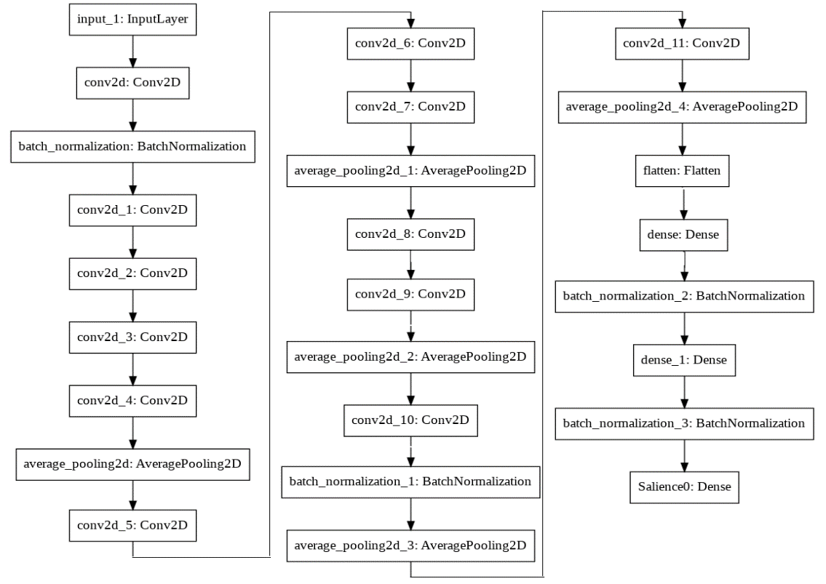

Figure 17 CNN model architecture

Following is the summary of CNN model architecture:

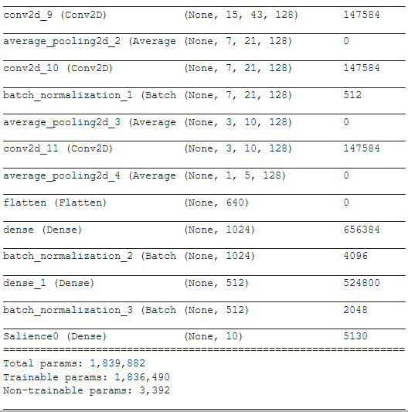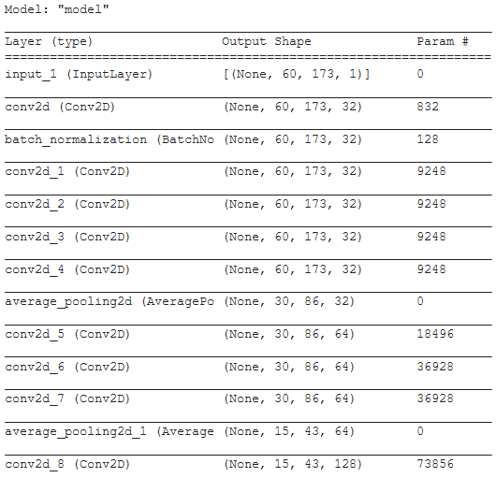

Figure 18 summary of the model architecture

1. Compiling, Training and Testing
2. For compiling

*model.compile(optimizer='adam',*

*loss='categorical_crossentropy',*

*metrics=['accuracy'])*

1. For Training

*model.fit(x_train, y_train,*

*batch_size=256,*

*epochs=200,*

*callbacks=[PlotLossesKeras()],*

*verbose=1,*

*validation_data=(x_val, y_val))*

1. For Testing

*score = model.evaluate(x_test, y_test)*

*print(score)*

### 3.5.6 Implementation of RNN Model

1. Data Preprocessing:
2. In data preprocessing, we simply convert sound into numpy array

*import librosa*

*sound,sr=librosa.load(PATH,res_type='kaiser_fast')*

1. After that we choose any of the any of the above explained method i.e. Repeating sound, Zero Padding at the end to remove inconsistency.
2. After that we extract features with sound numpy array

For example with mfcc feature extraction:

*mfccs = librosa.feature.mfcc(sound, sr=sr,n_mfcc=40)*

1. Repeated all the above steps for all the every sound
2. Collection of above data is use for training, testing and validation of the RNN model

1. Model Creation:

We imported all the library we needed to do so.

Here, is the code of the model

*inputs= Input(shape=(1,60,173,1))*

*model=TimeDistributed(Conv2D(filters=32,kernel_size=(5,5),padding='SAME',activation='relu'))(inputs)*

*model=TimeDistributed(BatchNormalization(momentum=0.2))(model)*

*model=TimeDistributed(AveragePooling2D(pool_size=(2,2)))(model)*

*model=TimeDistributed(Conv2D(filters=64,kernel_size=(3,3),padding='SAME',activation='relu'))(model)*

*model=TimeDistributed(AveragePooling2D(pool_size=(2,2)))(model)*

*model=TimeDistributed(Conv2D(filters=128,kernel_size=(3,3),padding='SAME',activation='relu'))(model)*

*model=TimeDistributed(AveragePooling2D(pool_size=(2,2)))(model)*

*model=TimeDistributed(Conv2D(filters=128,kernel_size=(3,3),padding='SAME',activation='relu'))(model)*

*model=TimeDistributed(BatchNormalization(momentum=0.2))(model)*

*model=TimeDistributed(AveragePooling2D(pool_size=(2,2)))(model)*

*model=TimeDistributed(Flatten())(model)*

*model=LSTM(64,return_sequences=True)(model)*

*model=Flatten()(model)*

*output=Dense(10,activation='softmax',name='output')(model)*

*model=Model(inputs=inputs,outputs=[output])*

1. Model Architecture

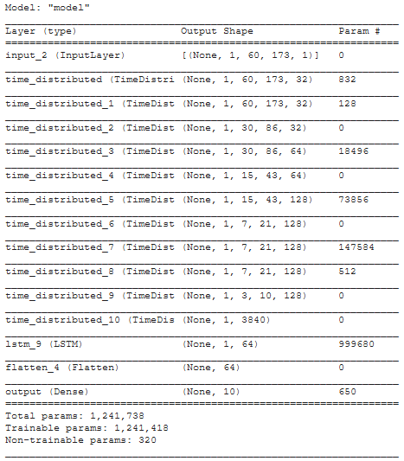

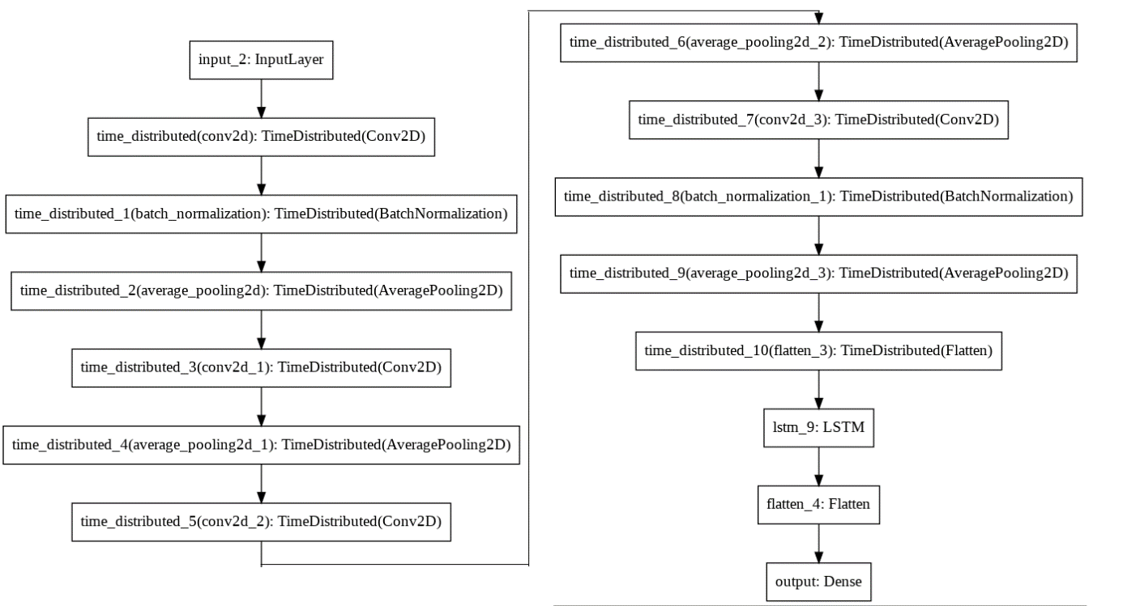

1. Compiling, Training and Testing
2. For compiling

*model.compile(optimizer='adam',*

*loss='categorical_crossentropy',*

*metrics=['accuracy'])*

1. For Training

*model.fit(x_train, y_train,*

*batch_size=256,*

*epochs=200,*

*callbacks=[PlotLossesKeras()],*

*verbose=1,*

*validation_data=(x_val, y_val))*

1. For Testing

*score = model.evaluate(x_test, y_test)*

*print(score)*

### 3.5.7 Combining CNN models of 3 best audio features

As shown in fig. 19 , We pass the respective input to respective CNN model after that we merge the output and proceed by some dense and dropout layer and we train this model and we achieve the highest accuracy 94% with model .

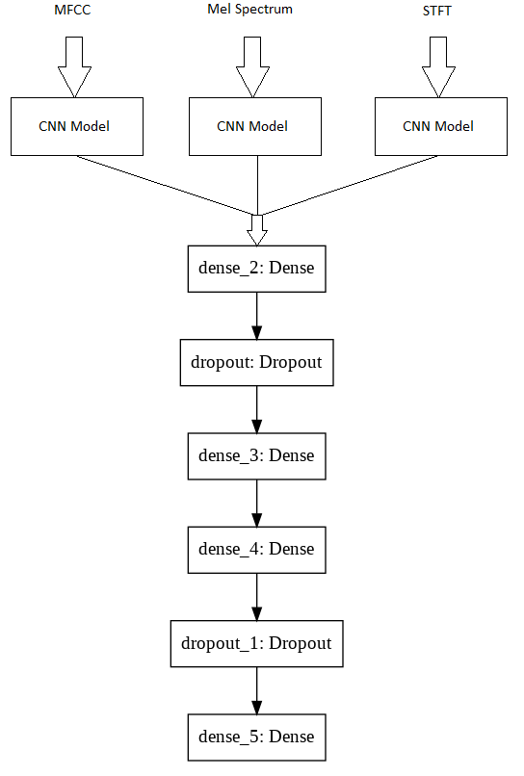

Figure 19: model architecture of combined 3 model

**Learning Graph of above model:**

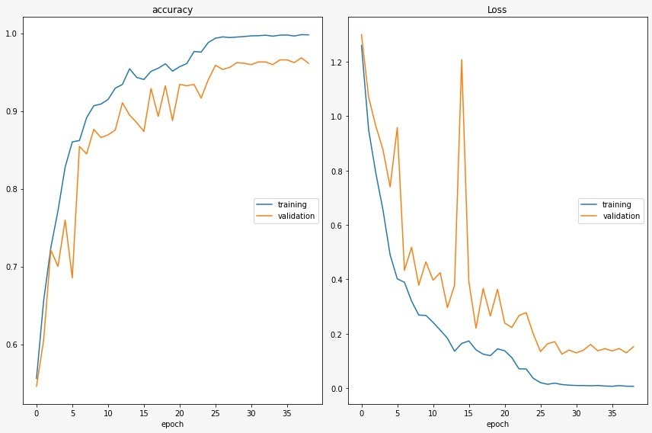

# 4 Result and Discussion

Our approaches in this project was identification and analysis of audio features as well as models that works effectively and produces high accuracy with the given datasets. We have tested various features on different models namely ANN (Artificial Neural Network) , CNN(Convolutional Neural Network) and RNN (Recurrent Neural Network). The three highest accuray has come out with the MFCC features(Mel Frequency Ceptral Coefficient ) , Mel Spectrum and STFT (Short Time Fourier Transfrom).

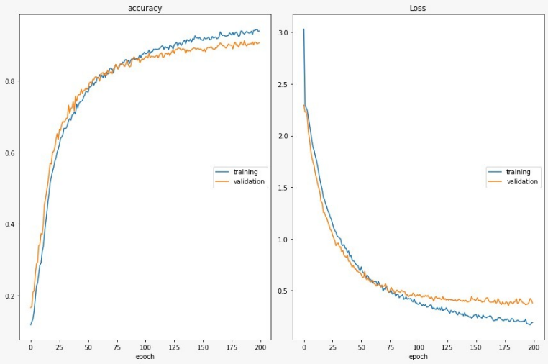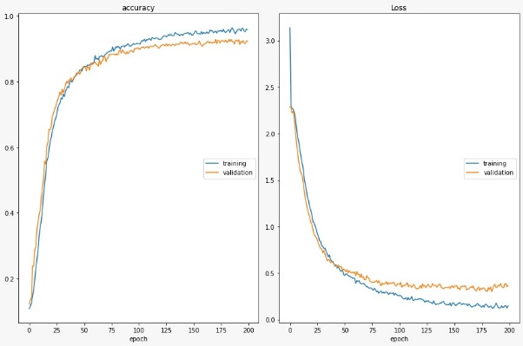Let us see learning graph of ANN models with MFCC, Mel Spectrum and STFT feature

1. (b)

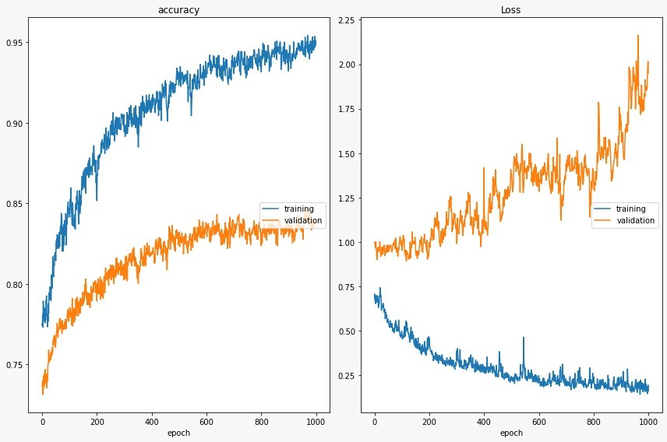

(c)

Figure 20: ANN learning graph with MFCC(a), Mel Spectrum(b) and STFT(c) features.

Here in fig.20 , we can see the learning graph of ANN model which was trained with MFCC features of the audio dataset.The left part of image is showing the accuracy versus epochs graph. Here for 200 epochs , the accuracy of training and validation is coming out to be very high . The learning rate of our model is increaing exponentially with increase in the epochs. Also in the right part of figure, the model loss has been depicted. Here we can see that with the increase in number of epochs, the training and validation loss of the model is decreasing exponentially and stops improving near 200th epochs.

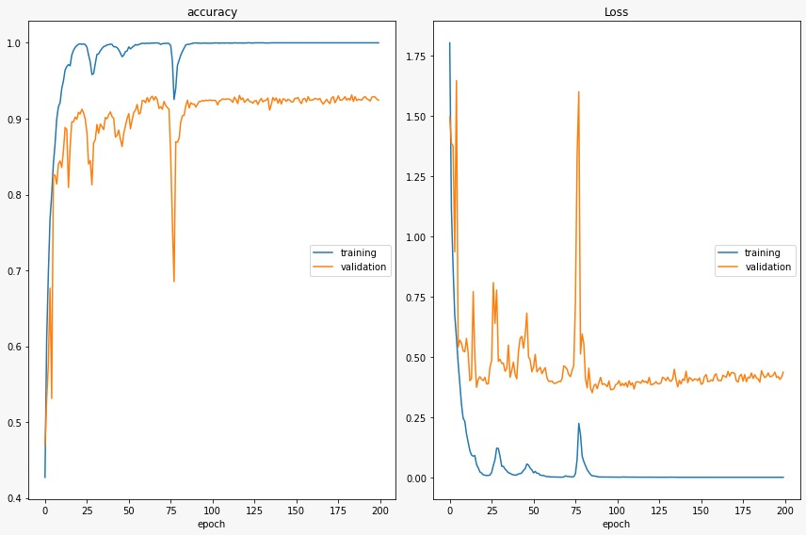

1. (b)

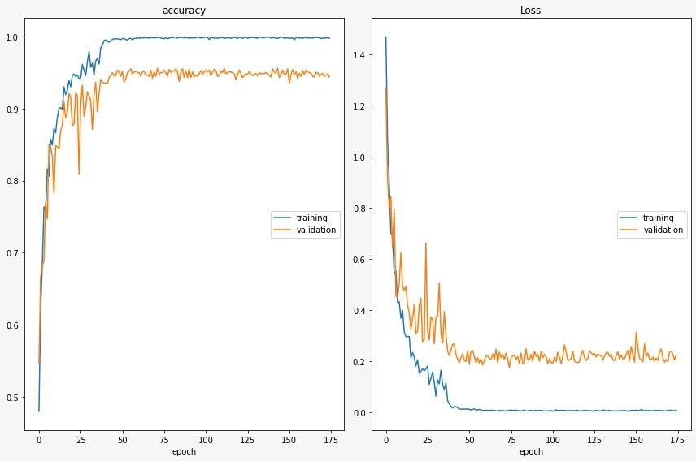

(c)

Figure 21 CNN model learning graph with MFCC(a), Mel Spectrum(b) and STFT(c) features

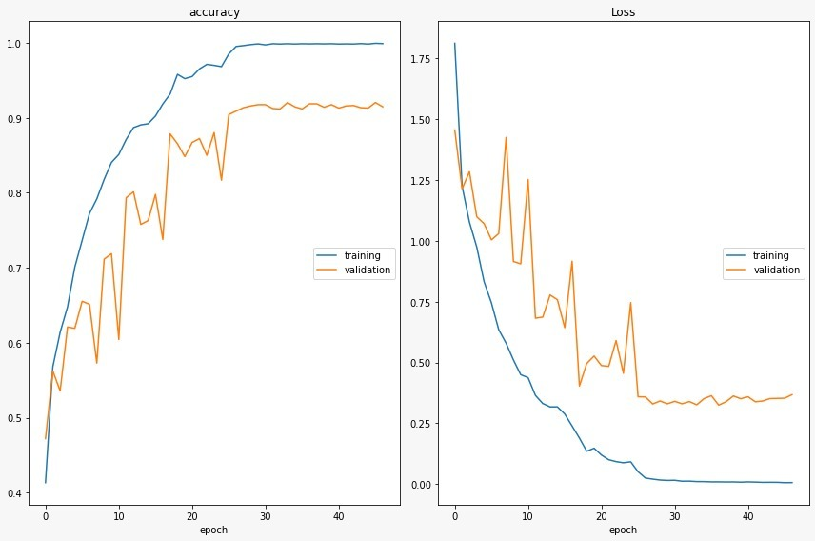In figure 21 , the learning graph of CNN model has been shown . This model was trained with the MFCC features.Here we can see that the model is giving the training accuracy almost near to 99 % , but validation accuacy has stopped improving with 100 -125th  epochs. Also in the right part of figure the training and validation loss is depicted. Here we see that training and validation error has stoppe decreasing in after about 100th epoch. Below in fig. 22 ,similarly learning graph for the RNN model is shown.

1. 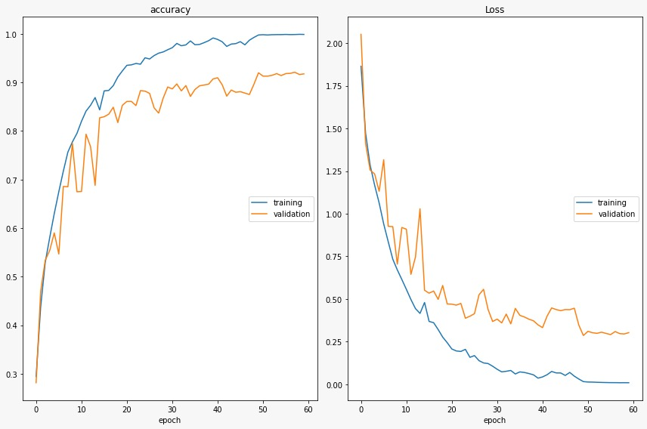 (b)

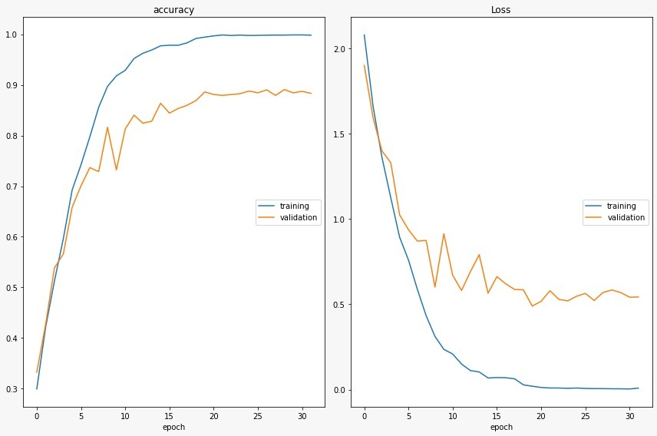

(c)

Figure 22 RNN model implementation with MFCC(a),Mel Spectrum(b) and STFT(c) feature

**Comparison of ANN vs CNN vs RNN**

Table 1 : accuracy of ANN, CNN and RNN with different audio fearures

|  |  |  |  |
| --- | --- | --- | --- |
|  | MFCC | Mel spectrum | STFT |
| ANN | 91% | 90% | 86% |
| RNN | 90% | 88% | 86% |
| CNN | 93% | 93% | 92% |

After implementing the three models ANN , RNN and CNN with the different features the maximum accuaccy comes with the MFCC and Mel Spectrum. Using the MFCC features the accuracy of ANN , RNN and CNN are 91 % , 90 % and 93 % respectively.Therefore, for MFCC the highest accuracy comes out to be with CNN. However if we compare the learning graph for all the three models, the learning graph of CNN is very high but some showing some flucatutions along with the upcoming epochs while in case with ANN the learning rate is little bit slow but it is not showing any fluctuations. From here it becomes clear that CNN will be giving the best accuracy for these datasets.

After that we fixed the working model as CNN and tried with combining MFCC, Mel Spectrogram and STFT. From each of these features, we get one-Dimensional array with each features showing the probabilities of each of possible target class. The output array came with all the features were combined into single array and then proceeded with some dense and dropout layer and trained . The accuacy from this method comes out to be highest among all other i.e. 94%.

# 5 Summary and Conclusion

## 5.1 Findings

In this project , we have worked with the various audio features extraction techniques and implemented them with three neural network models i.e. ANN , CNN and RNN.

After exexution we get the result that shows that with MFCC featues the best accuracy comes out using CNN model(93%) and also in case of Mel-Spectrogram and STFT , the best accuracy come out with CNN (93 % and 91 % respectively) followed by ANN and then RNN.

## 5.2 Conclusion

After implementing all the three methods ANN ,CNN and RNN, we reach to consulsion that the audio classfication works most accurately with CNN and talking about the features used then MFCC is the best features for the learning the model.However the learning graph is not smooth in case of CNN but the learning rage is high. The learning graph of CNN could be more better . Among all audio features, MFCC and Mel Spectrogram are two best among all avalible features.

## 5.3 Future Work

Overall the project was good in case of accuracy but the features extractions takes a lot of time . For running and trainng out models we need these features. So before we run our project , these features should be availabe in storage in proper format which are very pathetic in practical scenario.In the future , we would expect to figure out some other methods for extracting the features.The method should be fast and efficient .Furthermore in the future we would like to explore and implemnting LSTM and Convolutinal RNN on the urban datasets.

# 6 Appendix

## 6.1 Keras Library :

Keras is a high-level neural networks API, written in Python and capable of running on top of TensorFlow, CNTK, or Theano.

This library was developed focussing on fast experimentation.From the ideas to result , it helps to execute neutal netowork implementation with least possilbe delay.

* It allows for easy and fast prototyping (through user friendliness, modularity, and extensibility).
* It supports both convolutional networks and recurrent networks, as well as combinations of the two.
* This libraty runs seamlessly on CPU and GPU.s is a high-level neural networks API, written in Python and capable of running on top of TensorFlow, CNTK, or Theano.

## 6.2 Librosa Library :

Librosa is a package in python which is used for audio and music analysis. This library helps in preprossing of the audio files and provides various funcions which can extract the features from the loaded audio data.

In order to create a music information retrival system , this library provides the necessary building blocks. It can also be helpful in music generation as well as automatic speech recognition.

**Installation:**

* + **Using PyPI** (Python Package Index ) : To install using python package index , we can installed librosa library by runnng following command in terminal :
    - *pip install librosa*
    - *sudo pip install librosa (in case of linux)*
  + **Conda Install :** In case of conda /Anaconda environment , librosa can be installed form the Andconda prompt by running following command :
    - conda install -c conda-forge librosa

## 6.3 RNN (Recurrent Neural Network)

Recurrent Neural Network is simply a generalised form of feedforward Neural Netowrk which has an internal memorty. For every input of data , the RNN performs the same function but the output of the current input depends on the output of past one , therfore we called RNN , recurrent in Nature. After the output is generated it is sent back into the recurrent network . Therefore for making a decision , RNN considers both : the current input and the output that has been learned in the previous input.



Figure 23 RNN model working flow diagram

Let us understand with figure 12 .First it takes x(0) from the input sequence and then it computes output h(0) . This h(0) along with the x(1) will be the input for the next step. Similarly the computed output h(1) from this state along with the x(2) will be the input for the next step and so on.

The formula[8] for the current state is :

ht = tanh(Whhht-1 + WxhXt)

where W is weight , Whh represents the weight of the previous state , Wxh is the weight at current input and tanh is a type of activation function , that are non-linear in nature and output values between -1 to +1. It’s equation[8] is :

tanh(x) = 2/(1 + e-2x) - 1

The formlua[8] for the output state in RNN is :

Yt =Whyht

Where Yt  represents output state and Why represnets the weight at the output state.

## 6.4 ANN (Artificial Neural Network)

Artificaial Neural Network can be simply called Neural Network. ANN model consists of a collection of simulated neurons. Each neuron in ANN is a node which is well connected to other nodes via the links that correspond to the biological axon-synapse-dendrite connections. All the links have their own weight, which determine the strengths of node's influence on other nodes.



Figure 24 represneting an Artificial Neural Network

In figure 10, circles have been used to denote the **neuron** inside the network.The circles which are labelled as +1 are known as bias units and mainly corresponds to the term Intercept.

* The leftmost layer present in the netowk is called **input layer** which is used to feed the input to the model .
* The middle layer present in the network is known as **hidden layer**.This layer is called hidden because in the training set , values of this layer is not observed.
* The rightmost layer present in the network is known as **output layer** which gives us the output of the model.

**Mathematical expression** [7] :

Artificial Neural Network consists of basic computational units called neurons.Let us assume for each neuron , it takes input as x1 , x2, x3,.. xk.

Fout = fsigmod(WT x) = fsigmod( )

Where W is the weights and b is the bias. fsigmod is a sigmoid function . Sigmoid is one of the activation function and can be derived as :

fsigmoid (x) =

A simple neural network generally contains only one hidden layer, but it a neural network may contain multiple hidden layers.Let us suppose in layer k , there are n neurons and the sum of weighted input of ith neurons in kth layer is oi(k) then we get the oi(k+1) by following eqution[7] :

For k=1, oi(2) =

For k>=2

oi(k+1) =

**Backprogation algorithm:**

In order to calculate gradient of loss function , backpropagation algorithm is used . Basically we calculate gradient of loss function to train our neuralnetwork and in this way we can reduce the cost function.Let us suppose that L(W,b) is the loss function then parametes can be updated by following equations[7]:

